LEVEL 1: BASICS

1. Retrieve customer names and emails for email Marketing.
SELECT NAME, EMAIL FROM CUSTOMERS;

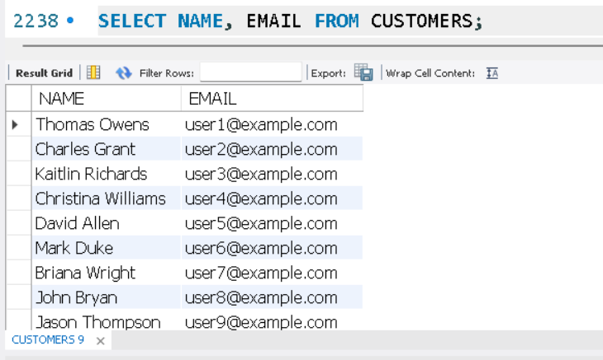

2. View complete product catalog with all available details.
SELECT * FROM PRODUCTS;

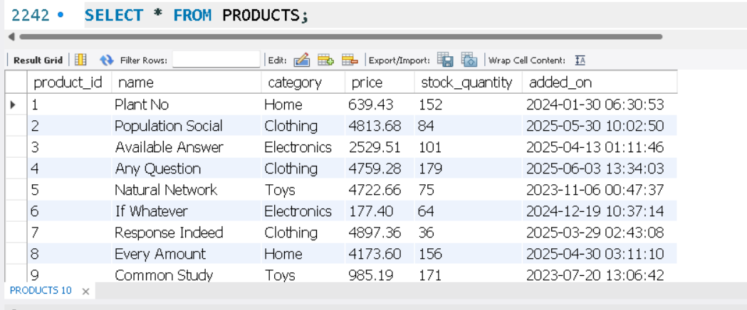

3. List all unique product categories.
SELECT DISTINCT CATEGORY FROM PRODUCTS;

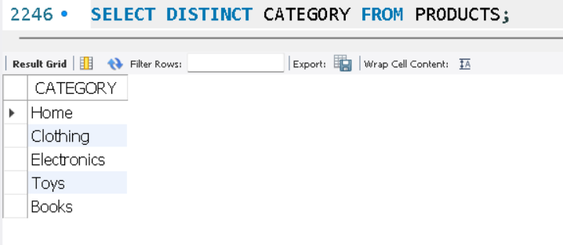

4. Show all products priced above ₹1,000.
SELECT * FROM PRODUCTS WHERE PRICE>1000;

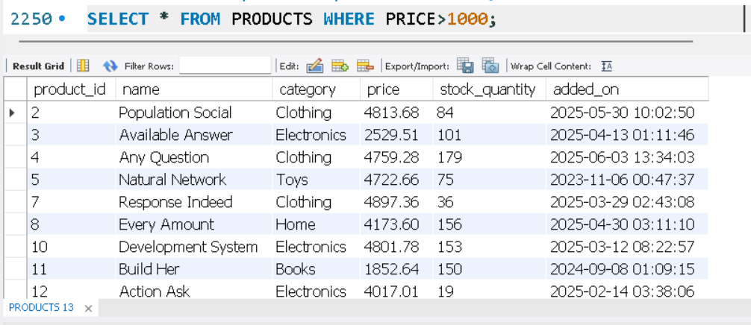

5. Display products within a mid-range price bracket (₹2,000 to ₹5,000).
SELECT * FROM PRODUCTS WHERE PRICE BETWEEN 2000 AND 5000;

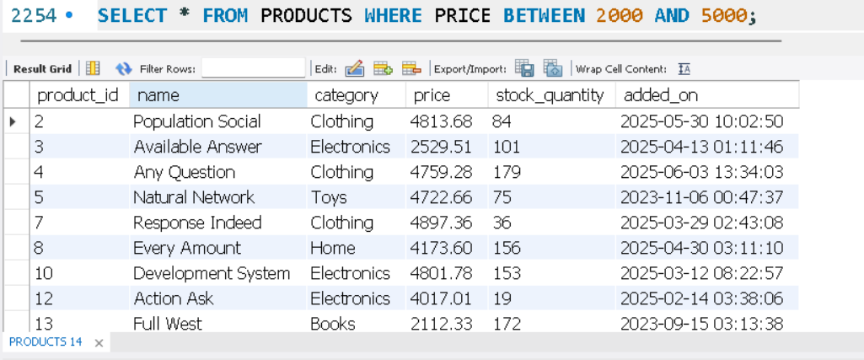

6. Fetch data for specific customer IDs (e.g., from loyalty program list).
SELECT * FROM ORDERS WHERE CUSTOMER_ID IN (6,18);

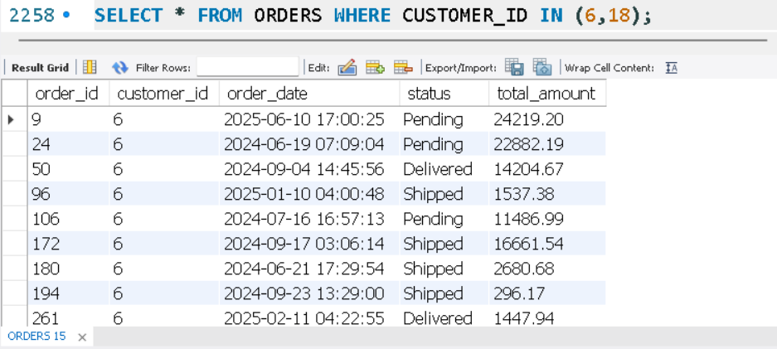

7. Identify customers whose names start with the letter 'A'.
SELECT * FROM CUSTOMERS WHERE NAME LIKE 'A%';

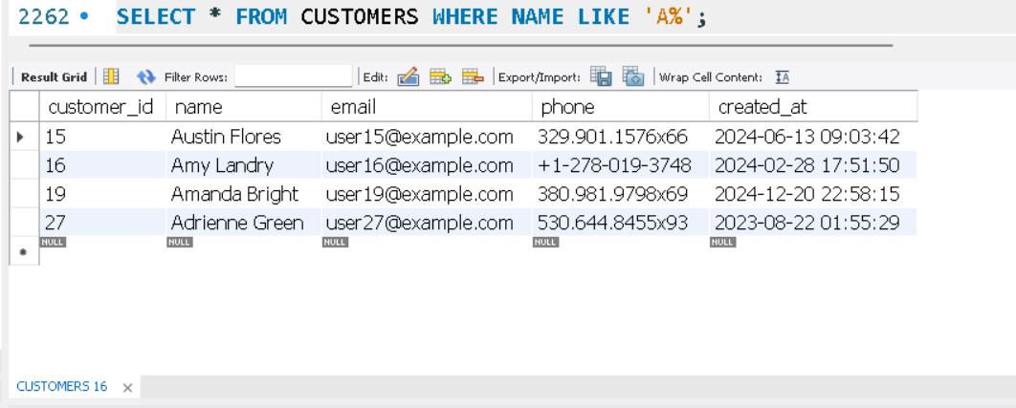

8. List electronics products priced under ₹3,000.
SELECT * FROM PRODUCTS WHERE CATEGORY='ELECTRONICS' AND PRICE<3000;

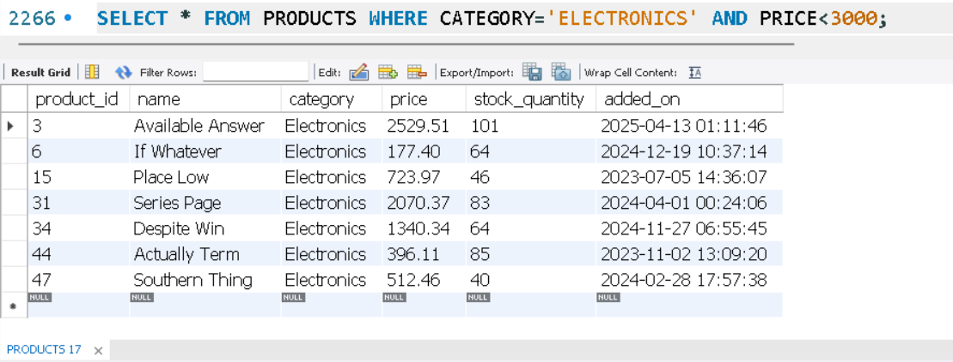

9. Display product names and prices in descending order of price.
SELECT NAME, PRICE FROM PRODUCTS ORDER BY PRICE DESC;

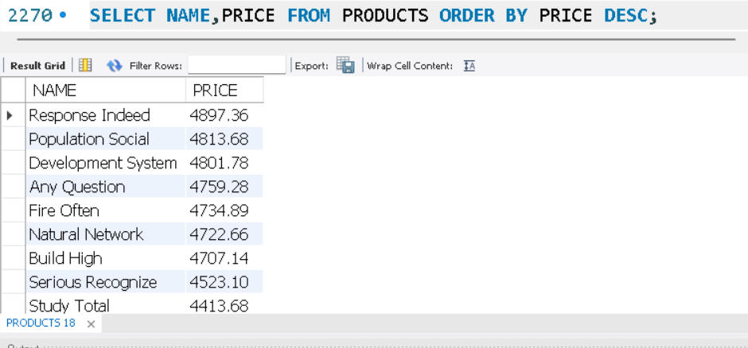

10. Display product names and prices, sorted by price and then by name.
SELECT NAME, PRICE FROM PRODUCTS ORDER BY PRICE, NAME;

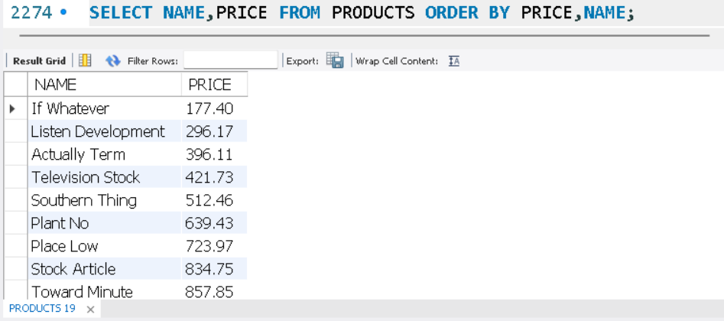

LEVEL 2: FILTERING AND FORMATING

1. Retrieve orders where customer information is missing (possibly due to data migration or deletion).
SELECT * FROM ORDERS WHERE CUSTOMER_ID IS NULL;

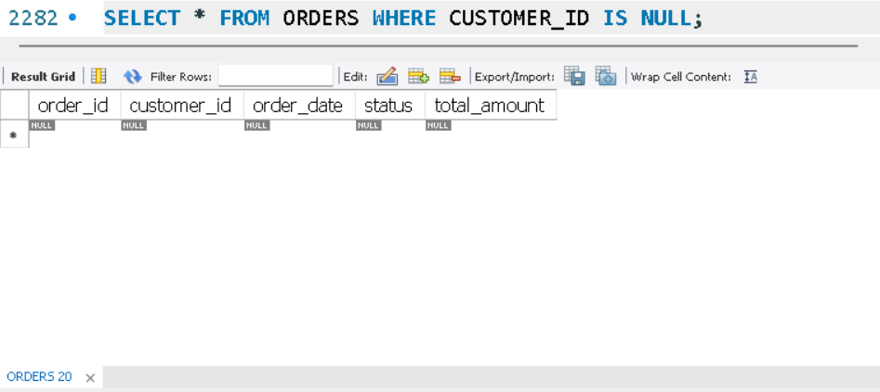

2. Display customer names and emails using column aliases for frontend readability.
SELECT NAME AS 'CUSTOMER NAMES', EMAIL AS 'CUSTOMER EMAILS' FROM CUSTOMERS;

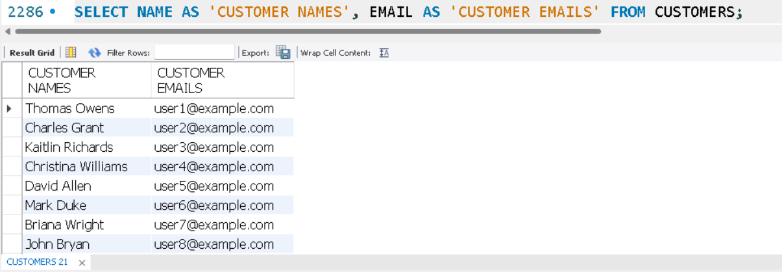
3. Calculate total value per item ordered by multiplying quantity and item price.
SELECT ORDER_ID, PRODUCT_ID, QUANTITY, ITEM_PRICE, (QUANTITY * ITEM_PRICE) AS 'TOTAL VALUE' FROM ORDER_ITEMS;

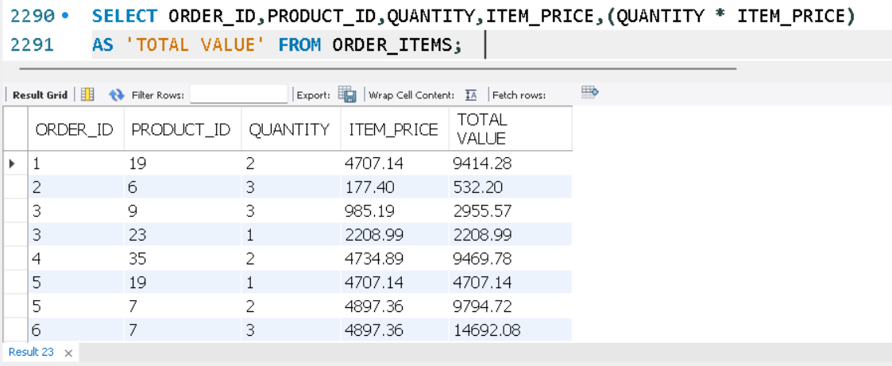

4. Combine customer name and phone number in a single column.
SELECT CONCAT (NAME,' - ', PHONE) AS 'CUSTOMER DETAILS' FROM CUSTOMERS;

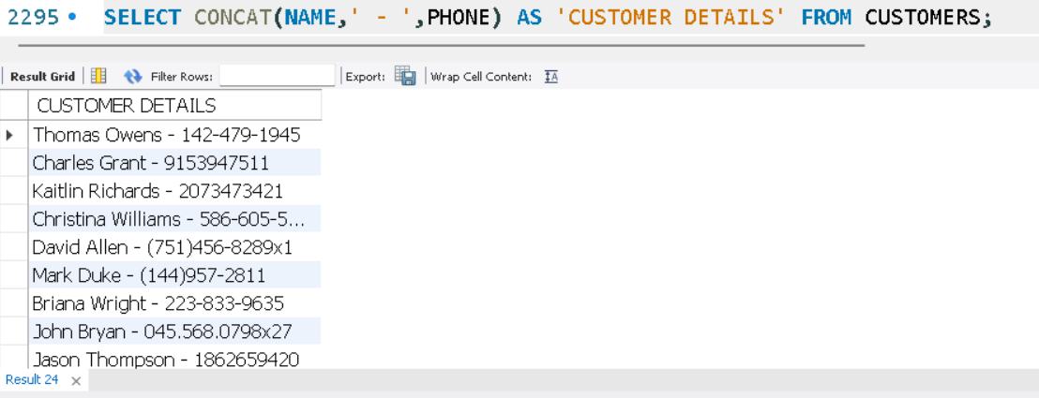

5. Extract only the date part from order timestamps for date-wise reporting.
SELECT ORDER_ID, DATE(ORDER_DATE) AS 'ONLY ORDER DATE' FROM ORDERS;

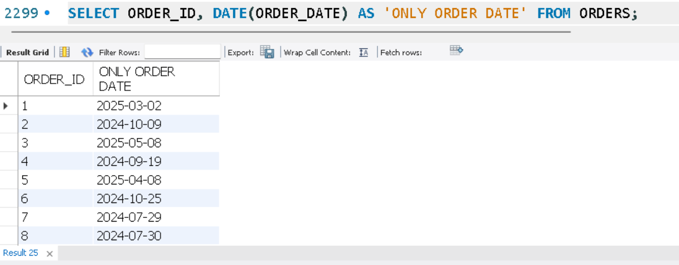

6. List products that do not have any stock left.
SELECT * FROM PRODUCTS WHERE STOCK_QUANTITY IS NULL;

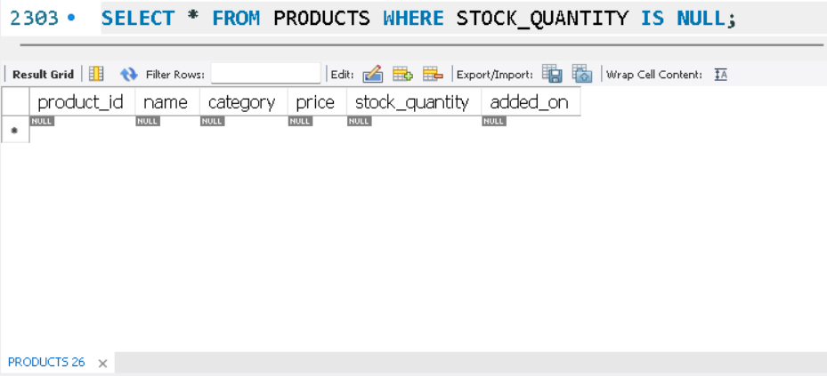
LEVEL 3: AGGREGATIONS

1. Count the total number of orders placed.
SELECT COUNT (*) AS 'TOTAL ORDERS' FROM ORDERS;

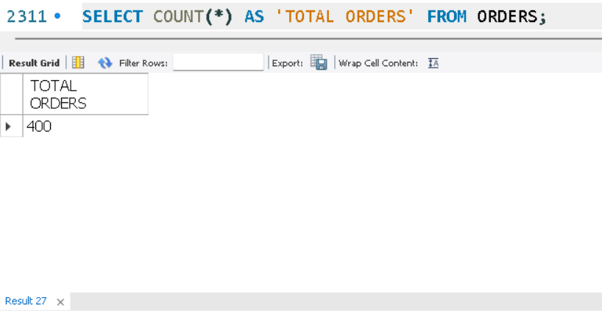

2. Calculate the total revenue collected from all orders.
SELECT SUM(AMOUNT_PAID) AS 'TOTAL REVENUE' FROM PAYMENTS;

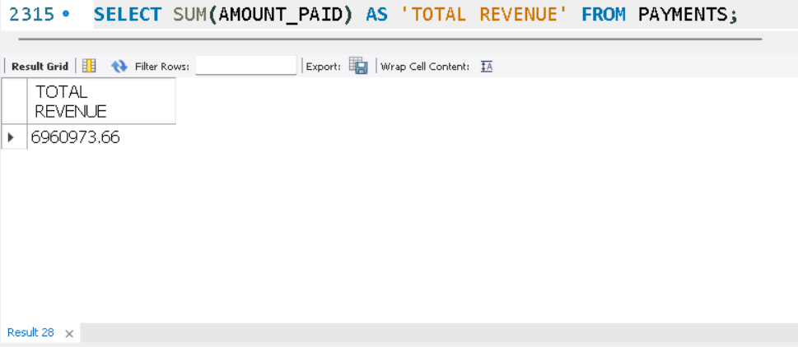

3. Calculate the average order value.
SELECT AVG(AMOUNT_PAID) AS 'AVERAGE ORDER VALUE' FROM PAYMENTS;

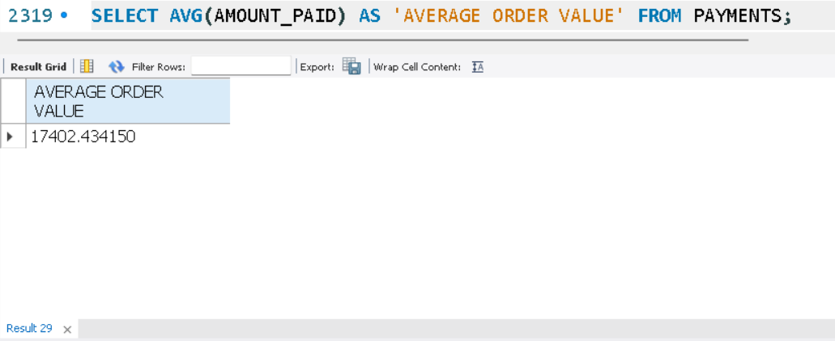

4. Count the number of customers who have placed at least one order.
SELECT COUNT (DISTINCT CUSTOMER_ID) AS 'ACTIVE CUSTOMERS' FROM ORDERS;

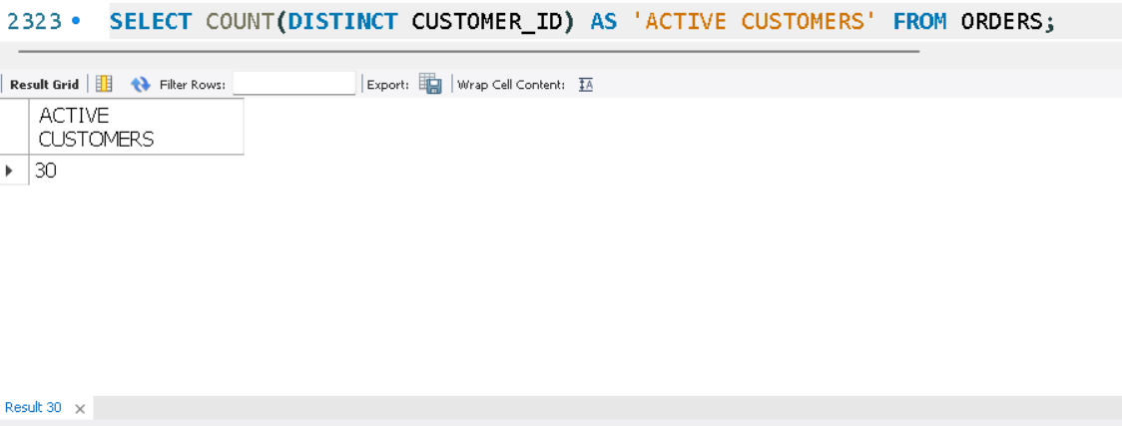

5. Find the number of orders placed by each customer.
SELECT CUSTOMER_ID, COUNT (*) AS 'NO. OF ORDER PLACED' FROM ORDERS GROUP BY CUSTOMER_ID;

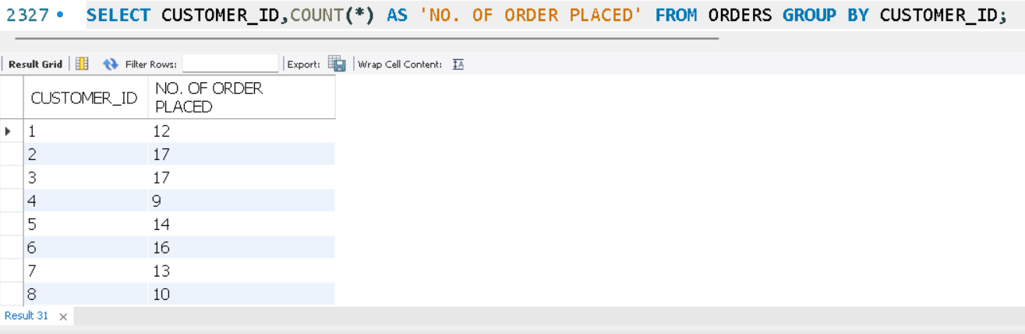

6. Find total sales amount made by each customer.
SELECT CUSTOMER_ID, SUM(TOTAL_AMOUNT) AS 'TOTAL SALES PER CUSTOMER' FROM ORDERS GROUP BY CUSTOMER_ID;

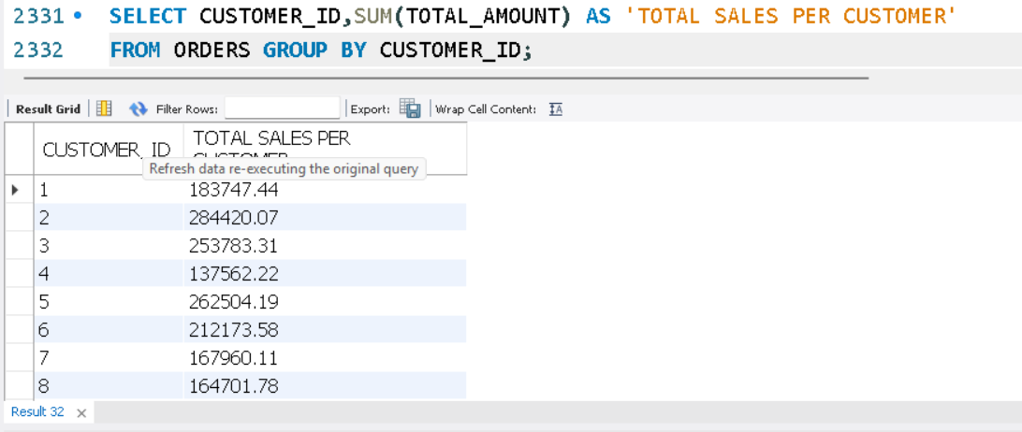

7. List the number of products sold per category.
SELECT P. CATEGORY, SUM (OI. QUANTITY) AS 'TOTAL PRODUCTS SOLD'FROM Products P JOIN ORDER_ITEMS OI ON P. PRODUCT_ID=OI.PRODUCT_ID GROUP BY P. CATEGORY;

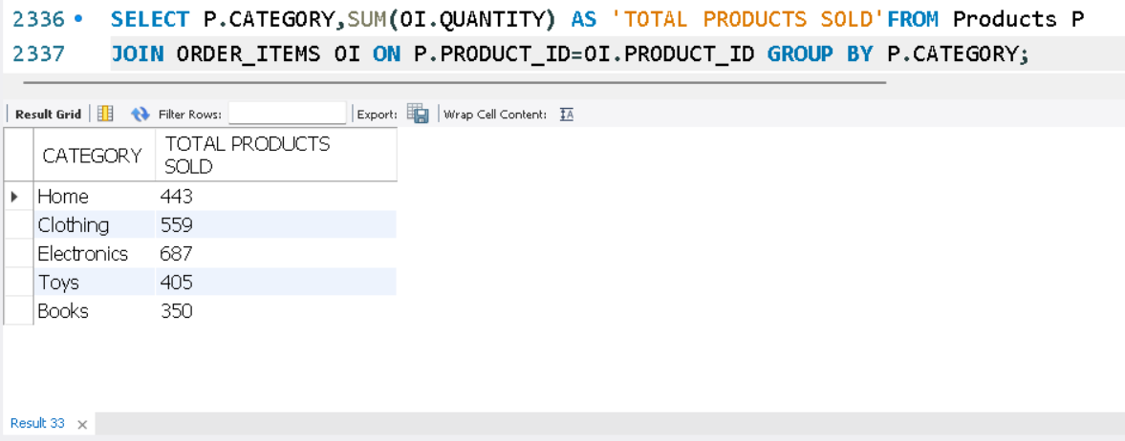

8. Find the average item price per category.
SELECT CATEGORY, AVG(PRICE) AS 'AVERAGE PRICE' FROM PRODUCTS GROUP BY CATEGORY;

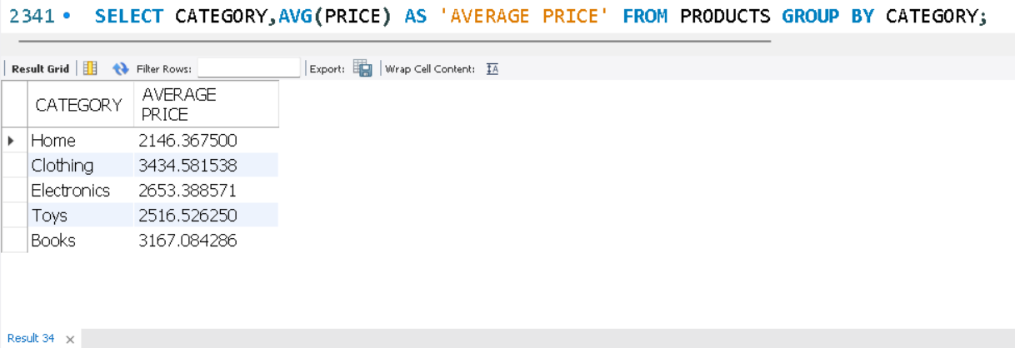

9. Show number of orders placed per day.
SELECT DATE(ORDER_DATE) AS 'ORDER_DAY', COUNT (*) AS 'TOTAL_ORDERS' FROM ORDERS
GROUP BY DATE(ORDER_DATE);

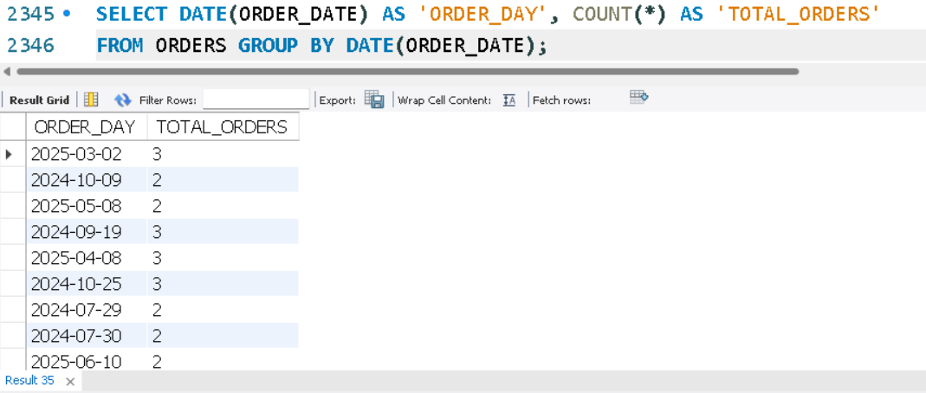

10. List total payments received per payment method.
SELECT METHOD, SUM(AMOUNT_PAID) AS 'TOTAL PAYMENTS' FROM PAYMENTS GROUP BY METHOD;

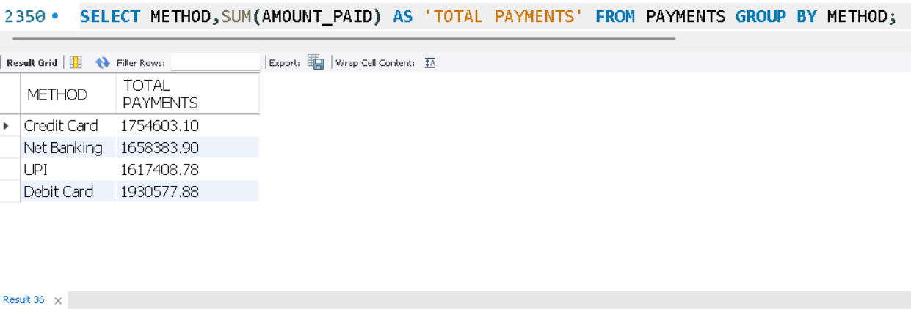

LEVEL 4: MULTI-TABLE QUERIES (JOINS)

1. Retrieve order details along with the customer name (INNER JOIN).
SELECT O.*, C.NAME FROM ORDERS O INNER JOIN CUSTOMERS C ON O. CUSTOMER_ID=C. CUSTOMER_ID;

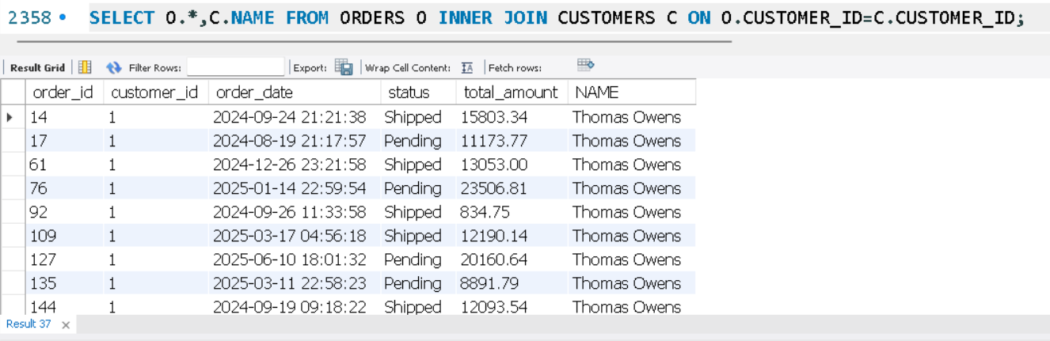

2. Get list of products that have been sold (INNER JOIN with order_items).
SELECT DISTINCT P. PRODUCT_ID, P.NAME FROM PRODUCTS P INNER JOIN ORDER_ITEMS OI ON OI. PRODUCT_ID=P.PRODUCT_ID;

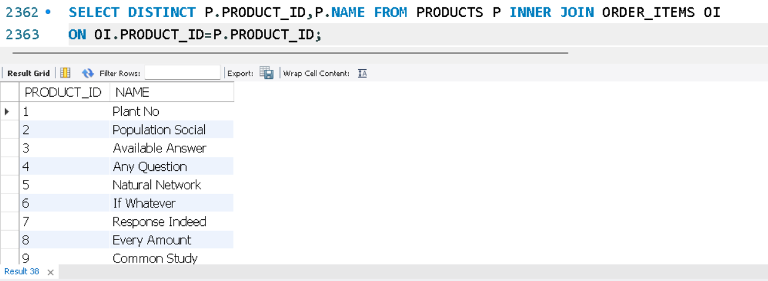

3. List all orders with their payment method (INNER JOIN).
SELECT O. ORDER_ID, PY. METHOD FROM ORDERS O INNER JOIN PAYMENTS PY ON O. ORDER_ID=PY.ORDER_ID;

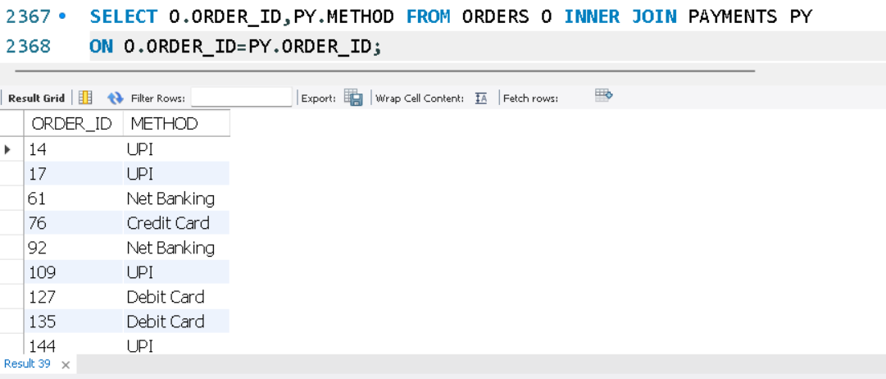

4. Get list of customers and their orders (LEFT JOIN).
SELECT C. CUSTOMER_ID, C.name, O. ORDER_ID FROM CUSTOMERS C LEFT JOIN ORDERS O ON C. CUSTOMER_ID=O.CUSTOMER_ID;

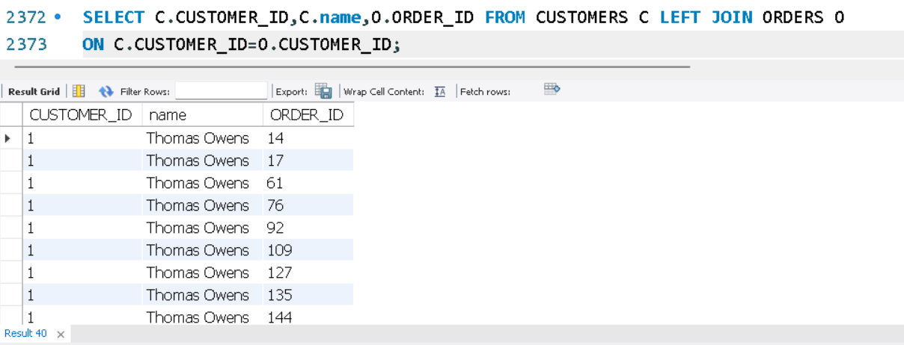

5. List all products along with order item quantity (LEFT JOIN).
SELECT P. PRODUCT_ID, P.NAME, OI. QUANTITY FROM PRODUCTS P LEFT JOIN ORDER_ITEMS OI ON P. PRODUCT_ID=OI.PRODUCT_ID;

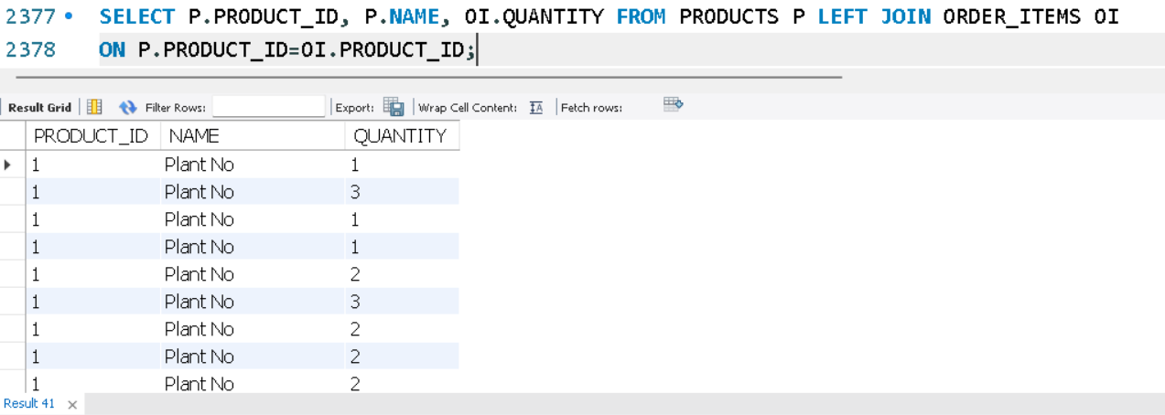

6. List all payments including those with no matching orders (RIGHT JOIN).
SELECT O. ORDER_ID, PY. PAYMENT_ID, PY. AMOUNT_PAID, PY. METHOD FROM ORDERS O RIGHT JOIN PAYMENTS PY ON O. ORDER_ID = PY. ORDER_ID;

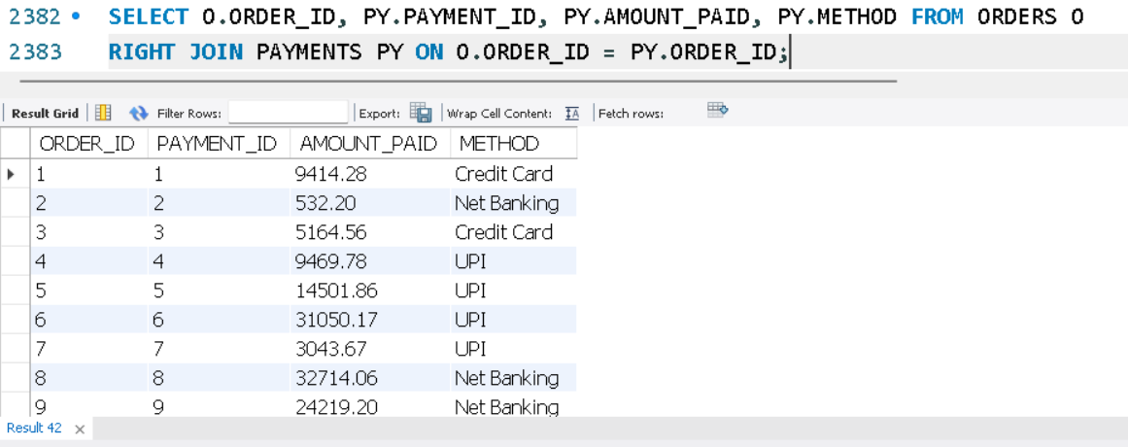

7. Combine data from three tables: customer, order and payment.
SELECT C.NAME, O. ORDER_ID, PY. AMOUNT_PAID FROM CUSTOMERS C INNER JOIN ORDERS O ON C. CUSTOMER_ID=O.CUSTOMER_ID INNER JOIN PAYMENTS PY ON O. ORDER_ID=PY.ORDER_ID;

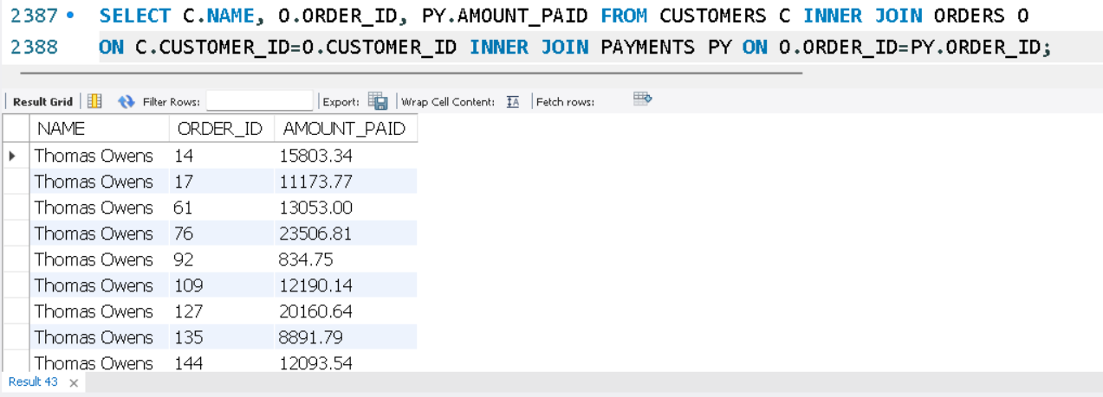

LEVEL 5: SUBQUERIES (INNER QUERIES)

1. List all products priced above the average product price.
SELECT * FROM PRODUCTS WHERE PRICE > (SELECT AVG(PRICE) FROM PRODUCTS);

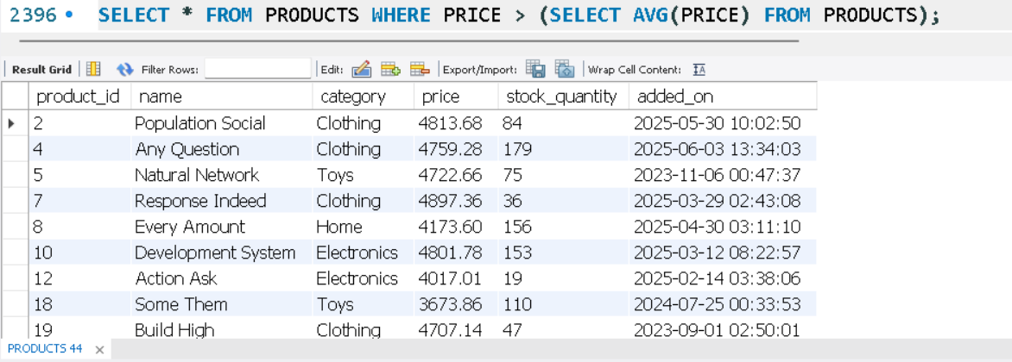

2. Find customers who have placed at least one order.
SELECT * FROM CUSTOMERS WHERE CUSTOMER_ID IN (SELECT CUSTOMER_ID FROM ORDERS);

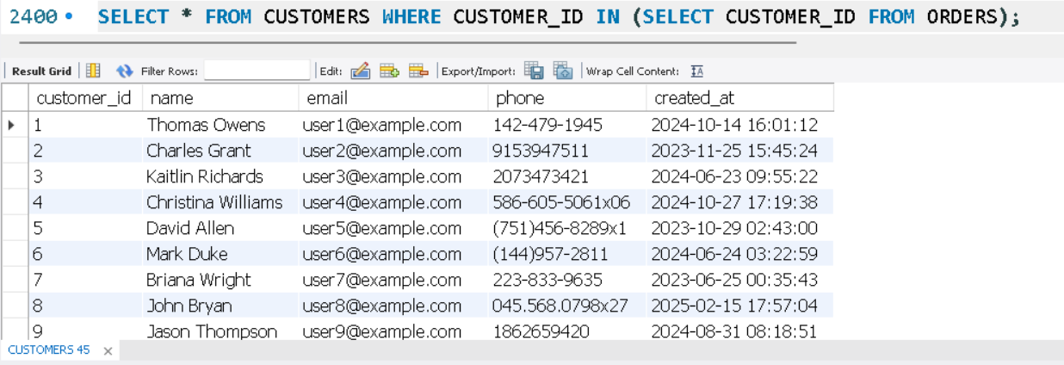

3. Show orders whose total amount is above the average for that customer.
SELECT * FROM ORDERS O WHERE TOTAL_AMOUNT > (SELECT AVG(TOTAL_AMOUNT) FROM ORDERS WHERE CUSTOMER_ID=O.CUSTOMER_ID);

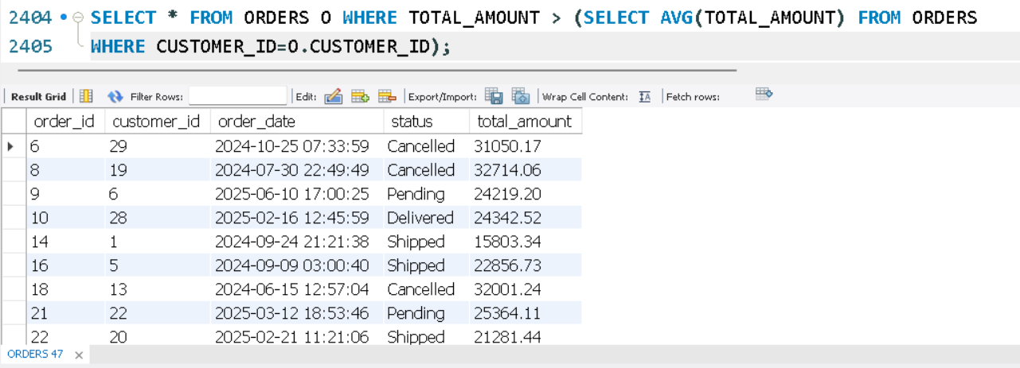

4. Display customers who haven’t placed any orders.
SELECT * FROM CUSTOMERS WHERE CUSTOMER_ID NOT IN (SELECT CUSTOMER_ID FROM ORDERS);

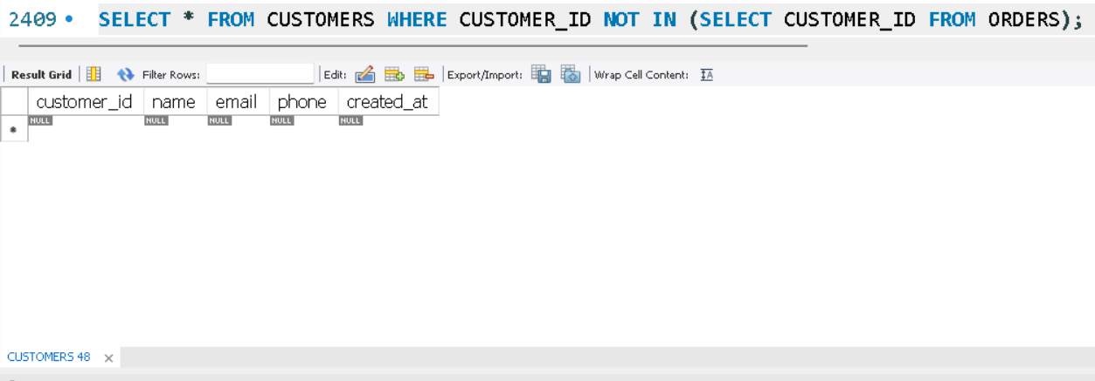

5. Show products that were never ordered.
SELECT * FROM PRODUCTS WHERE PRODUCT_ID NOT IN (SELECT PRODUCT_ID FROM ORDER_ITEMS);

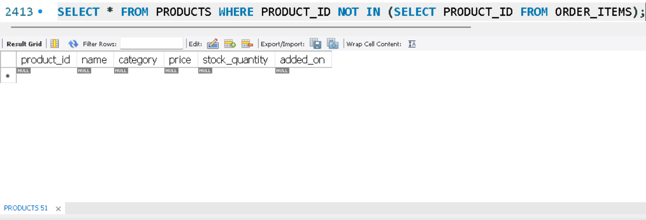

6. Show highest value order per customer.
SELECT O. ORDER_ID, O. CUSTOMER_ID, O. TOTAL_AMOUNT AS 'HIGHEST ORDER VALUE' FROM ORDERS O
WHERE TOTAL_AMOUNT = (SELECT MAX(TOTAL_AMOUNT) FROM ORDERS WHERE CUSTOMER_ID = O. CUSTOMER_ID);

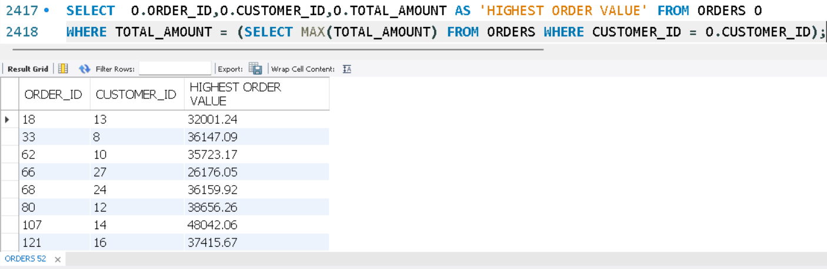

7. Highest Order Per Customer (Including Names).
SELECT C. NAME, O. ORDER_ID, O. TOTAL_AMOUNT AS 'HIGHEST ORDER' FROM CUSTOMERS C
JOIN ORDERS O ON C. CUSTOMER_ID=O.CUSTOMER_ID WHERE O. TOTAL_AMOUNT = (SELECT MAX(TOTAL_AMOUNT) FROM ORDERS WHERE CUSTOMER_ID = O. CUSTOMER_ID);

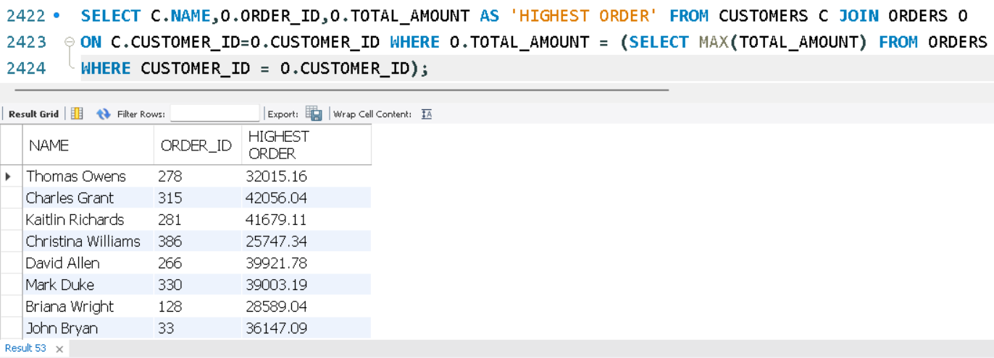

LEVEL 6: SET OPERATIONS

1. List all customers who have either placed an order or written a product review.
SELECT CUSTOMER_ID, NAME, EMAIL FROM CUSTOMERS WHERE CUSTOMER_ID
IN (SELECT CUSTOMER_ID FROM ORDERS UNION SELECT CUSTOMER_ID FROM PRODUCT_REVIEWS);

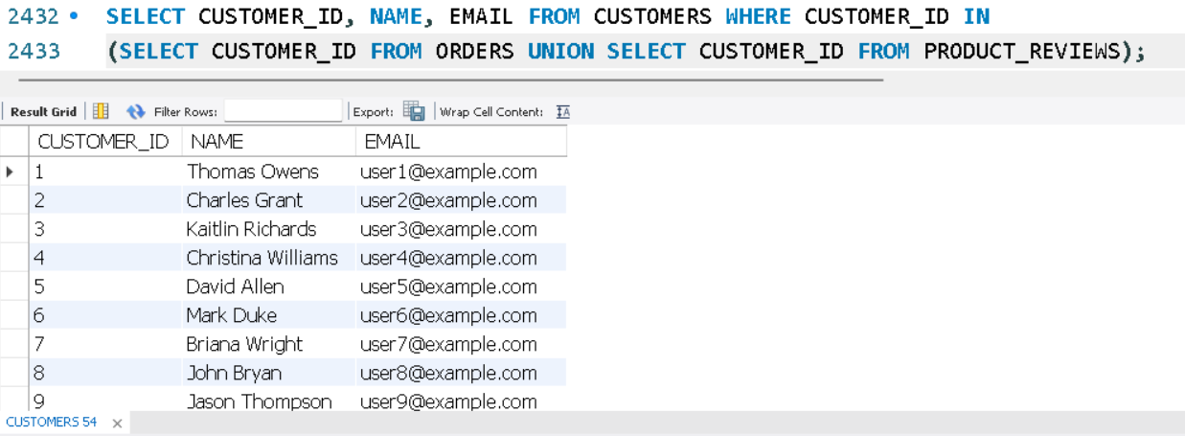

2. List all customers who have placed an order as well as reviewed a product.
SELECT CUSTOMER_ID, NAME, EMAIL FROM CUSTOMERS WHERE CUSTOMER_ID
IN (SELECT CUSTOMER_ID FROM ORDERS) AND CUSTOMER_ID IN (SELECT CUSTOMER_ID FROM PRODUCT_REVIEWS);

